Nepal College of Information Technology
Assessment
Spring 2010
Program : BE ELX/CE/IT Time : 3 hrs
Semester : Spring (II) FM : 100
Subject : OOP PM : 50

- Candidates are requested to give their answer as far as practicable in their own words.
- The figure in the margin indicates the full marks
- Attempt ALL question
1. a) Define classes and objects in OOP. 5
b) Explain agents and their responsibilities. 5
c) Explain identity, behavior and state of an object with suitable example. 5

2. a) What is abstraction mechanism? How do you implement it in terms of data? 7
b) Define a class CanteenMenu with suitable member variables and member functions, to initialize, take inputs and print the menu of a canteen as in the example below. 8

SN | Name | Price (Rs.) | Availability
1 | Tea | 7 | Yes
2 | Coffee | 10 | No

3. a) What are the different ways in which you can define a member function? What difference do they produce? Explain with example. 7
b) What is virtual function? Explain its role in achieving runtime polymorphism. Provide example wherever necessary. 8

4. a) Why inheritance is considered a powerful feature of OOP? Explain. List and briefly describe the various forms of inheritance. 7
b) An educational institution wishes to maintain records of its employees. The records are divided into a number of classes, whose hierarchical relationships are as in the figure below. The figure also shows minimum information required for each class. Specify all the classes and define functions to create the record and retrieve individual information as and when required. 8
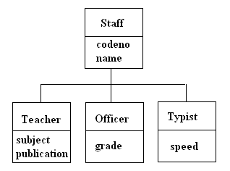

5. a) What are the different visibility modes available in C++? Why do we need protected mode? Explain with suitable example. 7
b) Define a class MyString to hold a string of characters. Overload the “+” operator to concatenate two objects of class MyString and assign it to a third object (s1=s2+s3). 8

6. a) What is generic programming? Write a program defining a generic class to hold a list of data. 8
b) What is container class and standard template library? 7
OR
Explain exception handling construct in C++.

7. Write short notes on (any two) 2*5
a) Stack vs. heap memory allocation
b) Is-a rule and Has-a rule
c) Overloading vs. Overriding
d) This pointer

